Discussion Assignment Unit 5
- How should the directory structure be designed to efficiently manage and access research papers, datasets, and documentation while ensuring a clear hierarchy, scalability, and access efficiency?
To efficiently manage and access research papers, datasets, and project documentation, the directory structure should adopt a multi-level hierarchy. The top-level directory can be labeled "Research Projects," under which there should be subdirectories for each specific project. Within each project directory, separate subdirectories should be created for "Research Papers," "Datasets," and "Documentation." This clear and logical hierarchy ensures that all related files are grouped, facilitating easy navigation and retrieval. Additionally, this structure reduces the likelihood of name conflicts and provides an organized framework that can scale as the volume of files increases (Silberschatz et al., 2013). Each subdirectory should be descriptive and consistent in naming conventions to further aid in efficient file management.
Scalability and access efficiency can be further enhanced by incorporating access control mechanisms and indexing features. Assigning appropriate permissions to different users or groups ensures that sensitive information is protected while allowing authorized personnel to access necessary files (Silberschatz et al., 2013). Furthermore, implementing indexing can significantly accelerate search operations, enabling users to quickly locate specific documents. Regular maintenance, such as archiving outdated files or optimizing storage, can prevent the directory from becoming cluttered and maintain system performance (Silberschatz et al., 2013). By adopting these strategies, the university’s computer science department can create a robust and scalable file storage system that supports its research endeavors effectively.
- What are the advantages and disadvantages of using a hierarchical directory structure versus a flat directory structure for organizing the university's research files? Discuss at least four advantages and disadvantages for each structure, providing relevant examples and conclusions.
A hierarchical directory structure
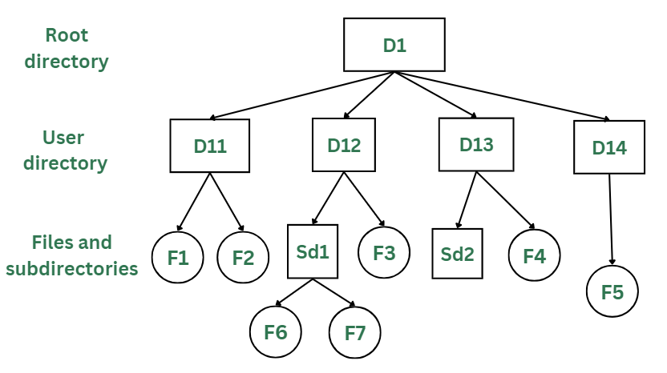
In designing a new file storage system for the university's computer science department, a hierarchical directory structure offers several advantages. Firstly, it allows for the creation of subdirectories within directories, making it easier to logically organize related files such as research papers, datasets, and project documentation (Geeks for Geeks, 2023). This structure enhances search efficiency since files are grouped by category, reducing the time required to locate specific documents.
Additionally, it provides improved security by restricting access at the directory level, ensuring sensitive data is protected. The hierarchical structure also facilitates backup and recovery processes, as related files can be easily identified and preserved (Geeks for Geeks, 2023). However, disadvantages include potential complexity in navigation as the number of subdirectories increases, limited file sharing among users since access to other users' directories is restricted, and the inability of users to modify root directory data (Geeks for Geeks, 2023).
A flat directory structure
Conversely, a flat directory structure is simpler to implement and understand, as all files reside in a single directory. This can be beneficial for small volumes of files, where naming conventions are strictly adhered to, making file creation, searching, and updating straightforward (Geeks for Geeks, 2023). However, as the volume of files grows, the flat structure presents significant challenges. The lack of subdirectories can lead to name collisions, making it difficult to maintain unique filenames. Searching for specific files becomes time-consuming as all files are in one directory (Geeks for Geeks, 2023).
Additionally, this structure does not support the logical organization of related files, leading to a cluttered and inefficient system. Lastly, backup and recovery processes become cumbersome, as it is challenging to identify and protect related files in a single directory (Geeks for Geeks, 2023). Thus, for a large and growing collection of research files, a hierarchical structure is generally more advantageous.
References
Geeks for Geeks. (2023, October 19). Structures of directory in operating system. https://www.geeksforgeeks.org/structures-of-directory-in-operating-system/
Silberschatz, A., Galvin, P., & Gagne, G. (2013). Operating system concepts essentials (2nd ed.). John Wiley & Sons, Inc

